**FINDING THE SHORTEST PATH PREVENTING SEXUAL HARASSMENT THROUGH ALGORITHMS**

|  |  |  |  |
| --- | --- | --- | --- |
| Juan Felipe Restrepo Buitrago  Universidad Eafit  Colombia  jfrestrepb@eafit.edu.co | Sara Valentina Cortes Manrique  Universidad Eafit  Colombia  svcortesm@eafit.edu.co | Andrea Serna Universidad Eafit Colombia asernac1@eafit.edu.co | Mauricio Toro  Universidad Eafit  Colombia  mtorobe@eafit.edu.co |

# **ABSTRACT**

Sexual harassment is a daily concern for Medellin’s women. Thanks to a Medellin’s mayoralty which made a survey to 1000 women, we know that 85% of them have suffered sexual harassment [4] (El 90,1 por ciento de la mujeres no denuncia el acoso callejero, 2019). We have to take control of this situation, due to the insecure feeling present in the majority of women, so they could live more calm and obviously comfortable going to anywhere. With this project we hope to create a solution to this problem using an algorithm to find a safer path which takes the least time posible to get from one location to another. Trying to avoid sexual harassment on the streets is imposible without considering crime, which helps us both, men and women, to feel less comfortable out in the city.

## **Key words**

|  |
| --- |
| Shortest route, street sexual harassment, identification of safe routes, crime prevention |

# **1. INTRODUCTION**

As we said lately, people don’t feel safe in the city and are worried, especially women. If the city were safer, surely our parents hadn’t taught us to be extremely cautious on the streets as the majority probably are. According to the given data by The Legal Medicine Nacional Institute in the first trimester of 2022 we had 6.336 violent homicides, 848 more than the first quarter of 2021. Medellin is in fact one of the most affected cities of the country by this matter with around 232 homicides [9] (Se registraron 6.336 muertes violentas en Colombia en el primer trimestre de 2022, 2022). Despite the fact that the number of cases in Medellin have reduced, people are still worried mostly for going out at night with a 35% of safeness according to what Medellin’s people think about crime in the last 3 years [3] (Criminalidad en Medellín, 2022). We want people to feel safer and more commfortable while going on the street.

# **1.1. The problem**

The problem we’re trying to solve is to find three paths to lead people to their destiny. One of them will be the shortest without having in mind the danger of the path is going through, other one will be the safest without having in mind the distance and the last one will consider proportionally both distance and safety. These three paths are important because of the situation the person using the algorithm is living through. In first place, if they need to hurry and get as quickly as possible to a place, they will probably avoid safety parameter, however on the other hand, someone could probably not need time, but safety or another person could need both parameters in their trip.

**1.3 Structure of the article**

Next, in Section 2, we present work related to the problem. Then, in Section 3, we present the datasets and methods used in this research. In Section 4, we present the algorithm design. Then, in Section 5, we present the results. Finally, in Section 6, we discuss the results and propose some directions for future work.

**2. RELATED WORK**

## Below, we explain four works related to finding ways to prevent street sexual harassment and crime in general.

## **2.1 Safetipin: A Free Map-Based Application, Which Helps Users to Which Areas They Would Like to Pass Through and Which Ones to Avoid.**

Safetipin is a mobile application which allows people to check whether a location is safe or not, and it finds the best paths to take people to a location avoiding unsafety places where dangers such as crime and street sexual harassment could occur. Although the safety of somewhere is mainly calculated by the Safetipin’s team, users can give their opinions of a place, improving the score’s accuracy of those places. Besides, people can tell the app which places they want to avoid. Safetipin was created by Kalpana Viswanath to treat the safety problem in Delhi [8] (Pareek, 2015).

Talking in algorithm terms, they are based on GIS to collect their information and their application runs machine learning [6] (Methodology , 2021) .

## **2.2 The Safe Route: Multi-Options Route Finder for Cyclists.**

The Safe Route is an application developed especially for bike drivers. This app provides the user multiple options of paths he could go through from the fastest to the largest and safest in terms of traffic and accidents. The Safe route was created by the company Futurice. The problem this app is considering is road insecurity for cyclists in Sweden. They hope to encourage people to ride a bike, giving them safe ways and helping the environment [5] (Lauri, 2022).

The parameters this app takes into account for providing a navigation based on safety are traffic jams, road work, crossings, poor surfaces, weather and accident statistics [10] (The Safe Route, n.d.). Data about the kind of algorithm this app uses is not given.

## **2.3 TomTom: Algorithms Prioritizing Safety Over Speed**

TomTom is an application, which finds routes to take people form one location to another. Lately this app is taking into account the safety of some roads above others. This new function was implemented because of the danger drivers were exposed to, one study was made in Finland that the fastest route to Koli National Park, was the most dangerous mainly on winter, because of the snow. So now this app takes parameters such as weather, quality of the road, etc. for finding a path [1] (Beedham, 2022).

TomTom’s engine is based on the A* algorithm [2] (Buve, n.d.).

## **2.4 Path Community: Red Flags on the Streets**

Path is an application that suggests routes in which the user is not likely to be involved into a harassment, assault or attack situation. It was created by Harry Mead. This is a user’s opinion-based application, where a user can highlight a dangerous area as red flags, which helps the app find the safest route to one point to another by avoiding these red flags [7] (Mustafa, 2022).

## **3. MATERIALS AND METHODS**

In this section, we explain how the data were collected and processed, and then different alternative path algorithms that reduce both the distance and the risk of sexual street harassment.

## **3.1 Data collection and processing**

The map of Medellín was obtained from *Open Street Maps* (OSM)[1]  and downloaded using the Python API[2] OSMnx. The map includes (1) the length of each segment, in meters; (2) the indication of whether the segment is one-way or not, and (3) the known binary representations of the geometries obtained from the metadata provided by OSM.

For this project, a linear combination (LC) was calculated that captures the maximum variance between (i) the fraction of households that feel insecure and (ii) the fraction of households with incomes below one minimum wage. These data were obtained from the 2017 Medellín quality of life survey. The CL was normalized, using the maximum and minimum, to obtain values between 0 and 1. The CL was obtained using principal components analysis. The risk of harassment is defined as one minus the normalized CL. Figure 1 presents the calculated risk of bullying. The map is available on GitHub[3] .

**Figure 1.** Risk of sexual harassment calculated as a linear combination of the fraction of households that feel unsafe and the fraction of households with income below one minimum wage, obtained from the 2017 Medellín Quality of Life Survey.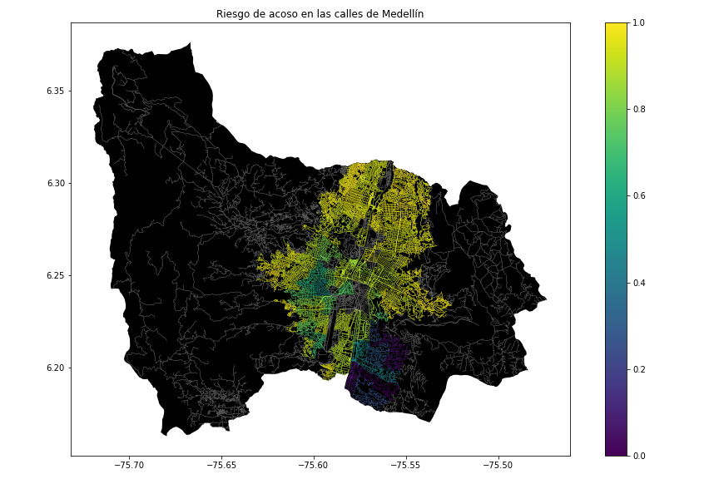

## **3.2 Algorithmic alternatives that reduce the risk of sexual street harassment and distance**

**3.2.1 Breadth-First Search**

Is an important graph search algorithm that is useful for analyzing and solving graph problems.

Breadth First Search starts by searching start node, followed by its adjacents nodes, then all nodes can be reached by a path from the start node containing two edges, three edges and so on. Normally, BFS visits all vertices in a graph *G* that are *k* edges away from the source vertex s before visiting any vertex *k + 1* edges away. This is done until no more vertices are reachable from *s.* [11] (Brilliant, Breadth-First Search (BFS), 2022)

**3.2.2 Depth First Search**

Is and algorithm for searching a graph or three data structure. The algorithm starts at the root (top) node of a tree and goes as far as it can down a given branch (path), then backtracks until it finds an unexplored path, and then explores it. The algorithm does this until the entire graph has been explored. [12] (Brilliant, Depth-First Search (DFS), 2022)

**3.2.3 Dijkstra's Shortest Path Algorithm**

It is an algorithm to find the shortest path from a starting node to a target node in a weighted graph. Dijkstra algorithm creates a tree of shortest paths from the starting vertex, the source, to all other points in the graph.

Dijkstra’s algorithm, published in 1959 and named after its creator Dutch computer scientist Edsger Dijkstra, can be applied on a weighted graph. The graph can either be directed or undirected. One stipulation to using the algorithm is that the graph needs to have a nonnegative weight on every edge. [13] (Brilliant, Dijkstra's Shortest Path Algorithm, 2022)

**3.2.4 Bellman-Ford Algorithm**

The **Bellman-Ford algorithm** is a graph search algorithm that finds the shortest path between a given source vertex and all other vertices in the graph. This algorithm can be used on both weighted and unweighted graphs.

Like Dijkstra's shortest path algorithm, the Bellman-Ford is guaranteed to find the shortest path in a graph. Though it is slower than Dijkstra's algorithm, Bellman-Ford is capable of handling graphs that contain negative edge weights, so it is more versatile. It is worth noting that if there exists a negative cycle in the graph, then there is no shortest path. [14] (Brilliant, Bellman-Ford Algorithm, 2022)

## In the following, we present different algorithms used for a path that reduces both street sexual harassment and distance.

## **4. ALGORITHM DESIGN AND IMPLEMENTATION**

## In the following, we explain the data structures and algorithms used in this work. The implementations of the data structures and algorithms are available on Github[4] .

## **4.1 Data Structures**

## Explain the data structure that was used to represent the map of the city of Medellín. Make a figure that explains it. Do not use figures from the Internet. *(In this semester, examples of data structures are adjacency matrix, adjacency list, adjacency list using a dictionary).* The data structure is presented in Figure 2.

**Figure 2:** An example street map is presented in (a) and its representation as an adjacency list in (b). (*Please feel free to change this graph if you use a different data structure*).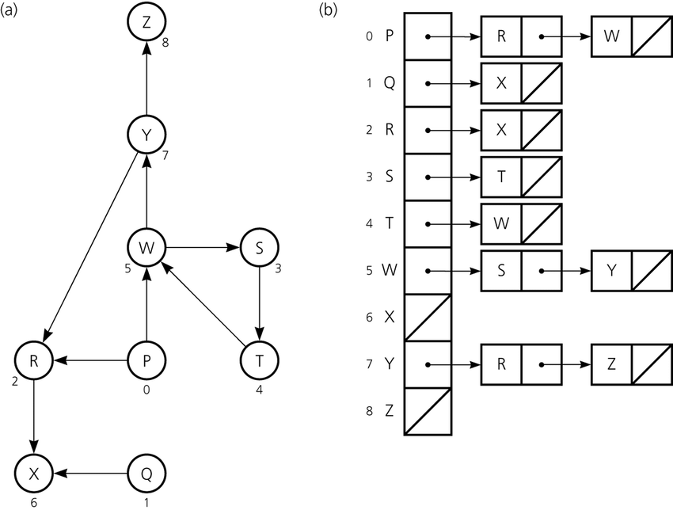

**4.2 Algorithms**

In this paper, we propose an algorithm for a path that minimizes both the distance and the risk of street sexual harassment.

**4.2.1 Algorithm for a pedestrian path that reduces both distance and risk of sexual street harassment**

Explain the design of the algorithm for calculating a path that reduces both distance and risk of harassment and make your own graph. Do not use graphs from the Internet, make your own. *(In this semester, the algorithm could be DFS, BFS, Dijkstra, A*, Bellman, Floyd among others ).* The algorithm is exemplified in Figure 3.

**Figure 3:** Calculation of a path that reduces both distance and risk of harassment (please feel free to change this figure if you use a different algorithm).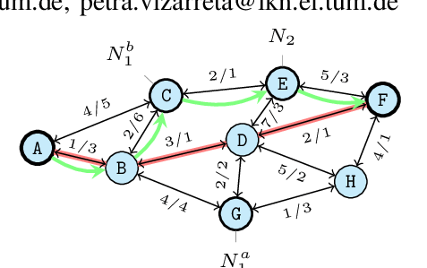

**4.2.2 Calculation of two other paths to reduce both the distance and the risk of sexual street harassment**

Explain the other two paths that reduce both distance and risk of street sexual harassment and make your own graph. Do not use graphs from the Internet, make your own. *(In this semester, the algorithm could be DFS, BFS, Dijkstra, A*, among others).* ) The algorithm is exemplified in Figure 4.

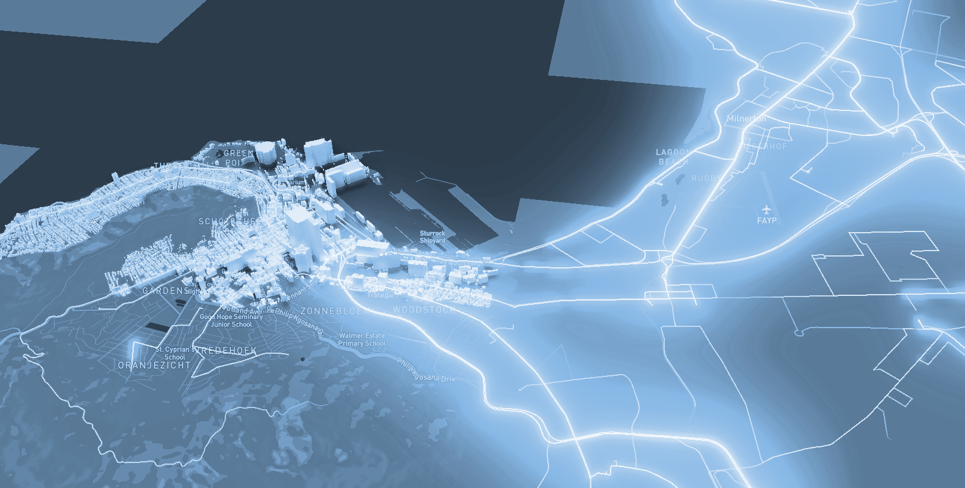

**Figure 4:** Map of the city of Medellín showing three pedestrian paths that reduce both the risk of sexual harassment and the distance in meters between the EAFIT University and the National University.

**4.3 Algorithm complexity analysis**

Explain, in your own words, the analysis, for the worst case, using the notation O. How did you calculate these complexities? Explain briefly.

|  |  |
| --- | --- |
| **Algorithm** | **Time complexity** |
| Algorithm name | O(V2 *E2 ) |
| Name of the second algorithm (in case you have tried two) | O(E3 *V*2V ) |

**Table 1:** Time complexity of the name of your algorithm, where V is.... E is... *(Please explain what V and E mean in this problem). No, do not use 'n'.*

|  |  |
| --- | --- |
| **Data Structure** | **Complexity of memory** |
| Name of the data structure | O(V*E*2E  ) |
| Name of the second data structure (in case you have tried two) | O(2E* 2V ) |

**Table 2:** Memory complexity of the data structure name used by your algorithm, where V is.... E is... *(Please explain what V and E mean in this problem). No, don't use 'n'. That is, don't use 'n'. Not 'n'.*

**4.4 Algorithm design criteria**

Explain why the algorithm was designed that way. Use objective criteria. Objective criteria are based on efficiency, which is measured in terms of time and memory. Examples of NON-objective criteria are: "I was sick", "it was the first data structure I found on the Internet", "I did it the last day before the deadline", "it's easier", etc. Remember: This is 40% of the project grade.

**5. RESULTS**

In this section, we present some quantitative results on the three pathways that reduce both the distance and the risk of sexual street harassment.

**5.1 Results of the paths that reduces both distance and risk of sexual street harassment**

Next, we present the results obtained from *three paths that reduce both distance and harassment,* in Table 3.

|  |  |  |  |
| --- | --- | --- | --- |
| **Origin** | **Destination** | **Distance** | **Risk** |
| Eafit | Unal | ?? | ?? |
| Eafit | Unal | ??? | ?? |
| Eafit | Unal | ?? | ?? |

Distance in meters and risk of sexual street harassment (between 0 and 1) to walk from EAFIT University to the National University.

**5.2 Algorithm execution times**

In Table 4, we explain the ratio of the average execution times of the queries presented in Table 3.

Calculate the execution time for the queries presented in Table 3.

## 

|  |  |
| --- | --- |
| **Calculation of v** | **Average run times (s)** |
| v = ?? | 100000.2 s |
| v = ?? | 800000.1 s |
| v = ?? | 8450000 s |

## **Table 4:** *Algorithm* name execution times *(Please write the name of the algorithm, e.g. DFS, BFS, A*)* for each of the three calculator paths between EAFIT and Universidad Nacional.

## **6. CONCLUSIONS**

Explain the results obtained. Are the paths significantly different? How useful is this for the city? Are the runtimes reasonable to use this implementation in a real situation? Which path would you recommend for a mobile or web application?

**6.1 Future work**

Answer, what would you like to improve in the future? How would you like to improve your algorithm and its application? Will you continue this project working on optimization? Statistics? Web development? Machine learning? Virtual reality? How?

# **ACKNOWLEDGEMENTS**

Identify the type of thank you you wish to write: to a person or to an institution. Keep the following guidelines in mind: 1. The professor's name is not mentioned because he or she is an author. 2. You should not mention the authors of articles that you have not contacted. 3. You should mention students, teachers of other courses who have helped you.

By way of example: This research has been supported/partially supported by [Name of Foundation, Donor].

We are grateful for help with [particular technique, methodology] to [First name Last name, position, name of institution] for comments that greatly improved this manuscript.

The authors thank Professor Juan Carlos Duque, Universidad EAFIT, for providing the data from the 2017 Medellín Quality of Life Survey, processed in a *Shapefile*.

# **REFERENCES**

1. Beedham, M. (2022, January 17). *How Routing Algorithms Can Prioritize Safety Over Speed*. Retrieved from TomTom: https://www.tomtom.com/blog/navigation/map-data-to-suggest-the-safest-route/
2. Buve, R. (n.d.). *What routing algorithms are most likely being used by navigation services like Garmin and TomTom? What factors are included in the final algorithm?*  Retrieve from Quora: <https://www.quora.com/What-routing-algorithms-are-most-likely-being-used-by-navigation-services-like-Garmin-and-TomTom-What-factors-are-included-in-the-final-algorithm>
3. *Criminalidad en Medellín*. (2022, August). Retrieved from NUMBEO: <https://es.numbeo.com/criminalidad/ciudad/Medell%C3%ADn>
4. *El 90,1 por ciento de la mujeres no denuncia el acoso callejero*. (2019, April 29). Retrieved from El Tiempo: <https://www.eltiempo.com/colombia/medellin/el-90-1-por-ciento-de-las-mujeres-no-denuncia-el-acoso-callejero-en-medellin-355056>
5. Lauri, J. (2022, March 14). *The Safe Route - improving the safety of cyclists in Sweden*. Retrieved from Futurice: https://futurice.com/blog/if-you-had-a-choice-would-you-select-speed-over-safety
6. *Methodology*. (2021). Retrieved form Safetipin: <https://safetipin.com/methodology/>
7. Mustafa, T. (2022, January 18). *New safety app helps you find the best route home*. Retrieved form Metro 50: <https://metro.co.uk/2022/01/18/new-safety-app-helps-you-find-the-best-route-home-15932866/#metro-comments-container>
8. Pareek, S. (2015, July 2). *An App that Helps You Decide the Safest Route Home*. Retrieve from: The Better India: https://www.thebetterindia.com/22908/app-helps-decide-safest-route-home/
9. *Se registraron 6.336 muertes violentas en Colombia en el primer trimestre de 2022*. (2022, May 5). Retrieved from infobae: <https://www.infobae.com/america/colombia/2022/05/05/se-registraron-6336-muertes-violentas-en-colombia-en-el-primer-trimestre-de-2022/>
10. *The Safe Route*. (n.d.). Retrieved from Futurice: <https://futurice.com/saferoute>
11. Brilliant. (2022, August 13). *Breadth-First Search (BFS)*. Retrieved from Brilliant.org: https://brilliant.org/wiki/breadth-first-search-bfs/
12. Brilliant. (2022, August 13). *Depth-First Search (DFS)*. Retrieved from Brilliant.org: https://brilliant.org/wiki/depth-first-search-dfs/
13. Brilliant. (2022, August 13). *Dijkstra's Shortest Path Algorithm*. Retrieved from Brilliant.org: https://brilliant.org/wiki/dijkstras-short-path-finder/
14. Brilliant. (2022, August 13). *Bellman-Ford Algorithm*. Retrieved from Brilliant.org: https://brilliant.org/wiki/bellman-ford-algorithm/

# Works Cited

Beedham, M. (2022, January 17). *How Routing Algorithms Can Prioritize Safety Over Speed*. Retrieved from TomTom: https://www.tomtom.com/blog/navigation/map-data-to-suggest-the-safest-route/

Brilliant. (2022, August 13). *Bellman-Ford Algorithm*. Retrieved from Brilliant.org: https://brilliant.org/wiki/bellman-ford-algorithm/

Brilliant. (2022, August 13). *Breadth-First Search (BFS)*. Retrieved from Brilliant.org: https://brilliant.org/wiki/breadth-first-search-bfs/

Brilliant. (2022, August 13). *Depth-First Search (DFS)*. Retrieved from Brilliant.org: https://brilliant.org/wiki/depth-first-search-dfs/

Brilliant. (2022, August 13). *Dijkstra's Shortest Path Algorithm*. Retrieved from Brilliant.org: https://brilliant.org/wiki/dijkstras-short-path-finder/

Buve, R. (n.d.). *What routing algorithms are most likely being used by navigation services like Garmin and TomTom? What factors are included in the final algorithm?* Retrieved from Quora: https://www.quora.com/What-routing-algorithms-are-most-likely-being-used-by-navigation-services-like-Garmin-and-TomTom-What-factors-are-included-in-the-final-algorithm

*Criminalidad en Medellín*. (2022, August). Retrieved from NUMBEO: https://es.numbeo.com/criminalidad/ciudad/Medell%C3%ADn

*El 90,1 por ciento de la mujeres no denuncia el acoso callejero*. (2019, April 29). Retrieved from El Tiempo: https://www.eltiempo.com/colombia/medellin/el-90-1-por-ciento-de-las-mujeres-no-denuncia-el-acoso-callejero-en-medellin-355056

Lauri, J. (2022, March 14). *The Safe Route - improving the safety of cyclists in Sweden*. Retrieved from Futurice: https://futurice.com/blog/if-you-had-a-choice-would-you-select-speed-over-safety

*Methodology* . (2021). Retrieved from Safetipin: https://safetipin.com/methodology/

Mustafa, T. (2022, January 18). *New safety app helps you find the best route home*. Retrieved from Metro 50: https://metro.co.uk/2022/01/18/new-safety-app-helps-you-find-the-best-route-home-15932866/#metro-comments-container

Pareek, S. (2015, July 2). *An App that Helps You Decide the Safest Route Home*. Retrieved from The Better India: https://www.thebetterindia.com/22908/app-helps-decide-safest-route-home/

*Se registraron 6.336 muertes violentas en Colombia en el primer trimestre de 2022*. (2022, May 5). Retrieved from infobae: https://www.infobae.com/america/colombia/2022/05/05/se-registraron-6336-muertes-violentas-en-colombia-en-el-primer-trimestre-de-2022/

*The Safe Route*. (n.d.). Retrieved from Futurice: https://futurice.com/saferoute

1. <https://www.openstreetmap.org/>
2. https://osmnx.readthedocs.io/
3. https://github.com/mauriciotoro/ST0245Eafit/tree/master/proyecto/Datasets
4. http://www.github.com/ ????????? /.../project/